Ray–Line Collinearity
# Source: AI Source: Provided by: [Data Path: Persons Table -> ID Column: 1, Name_En Column: Motasem Essam] -> From: [ChatGPT] on [7/25/2026]
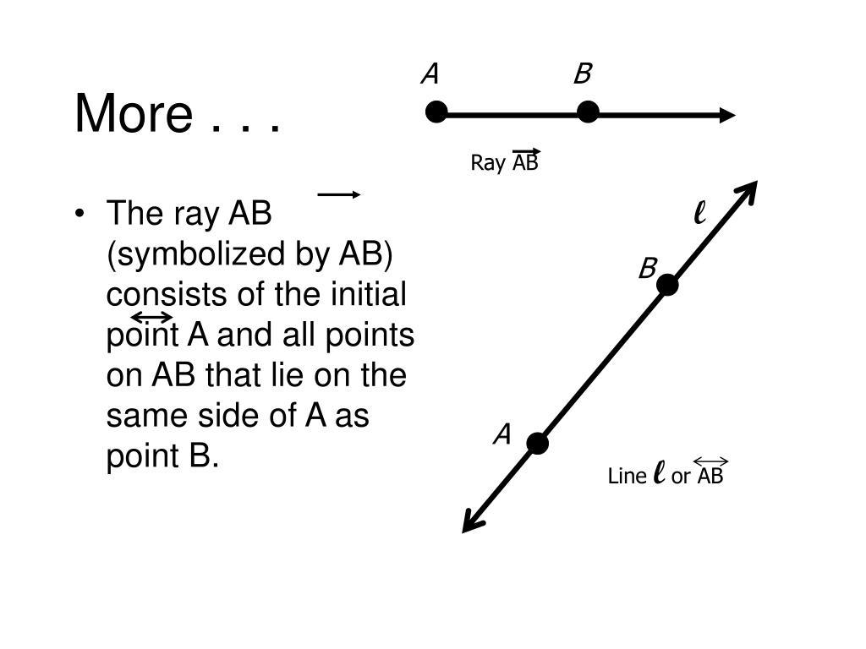
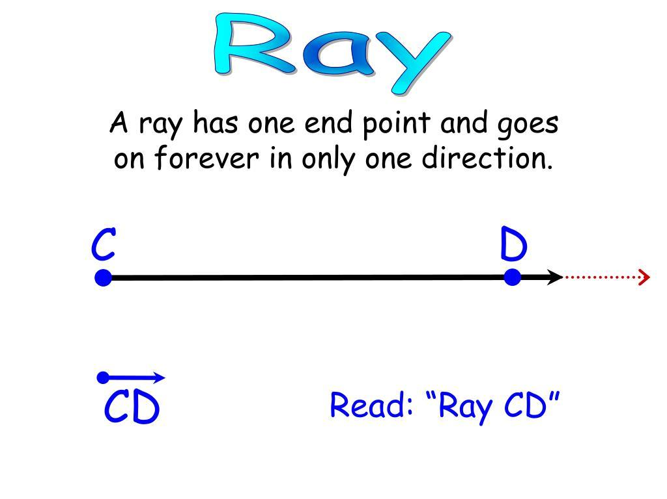
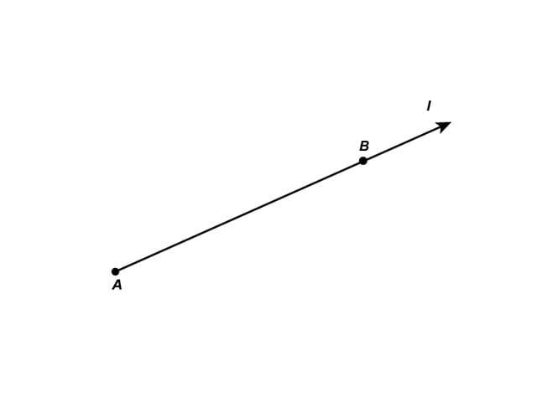
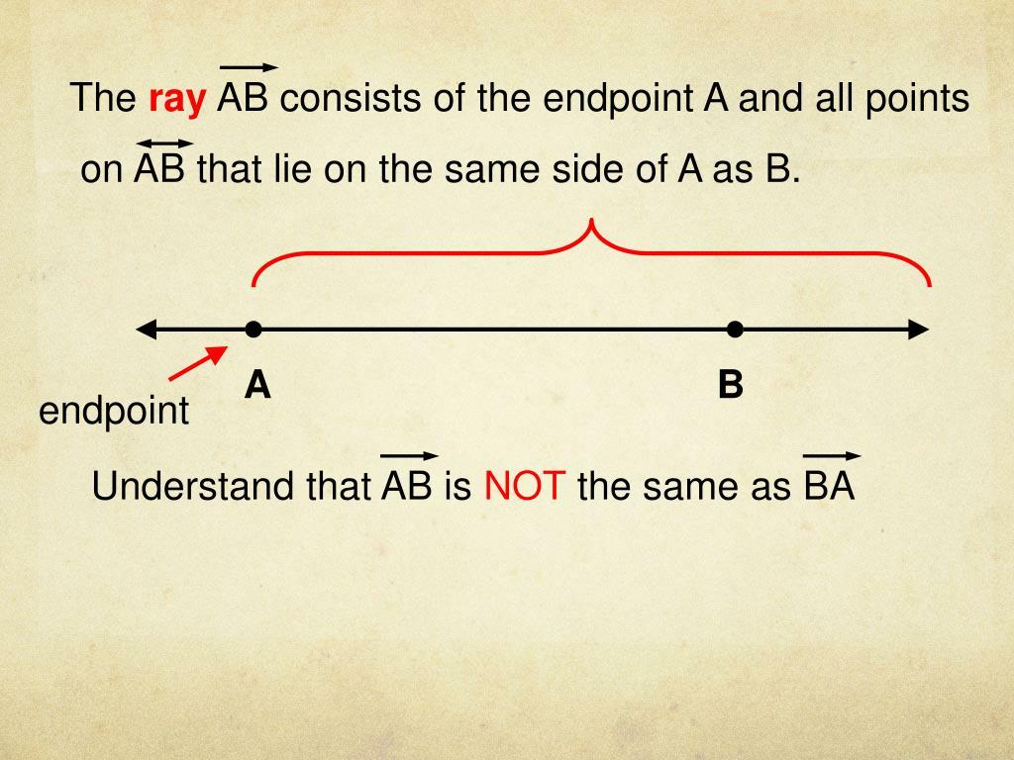

Definition
# Source: AI Source: Provided by: [Data Path: Persons Table -> ID Column: 1, Name_En Column: Motasem Essam] -> From: [ChatGPT] on [7/25/2026]
Ray–Line Collinearity is a geometric relationship in which a ray lies on a given straight line.
For a ray $\vec{AB}$and a line $l$, they are ray–line collinear when:
$$\boxed{\vec{AB}⊆l}$$
That means every point of the ray belongs to the line.
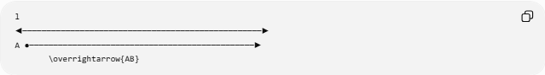
l
◀──────────────────────────────────────────────────▶
A ●───────────────────────────────────────────────▶
\overrightarrow{AB}
The ray is therefore a one-directional portion of the infinite line.

Fundamental Concept
# Source: AI Source: Provided by: [Data Path: Persons Table -> ID Column: 1, Name_En Column: Motasem Essam] -> From: [ChatGPT] on [7/25/2026]
A line extends infinitely in both directions:
◀──────────────────────────────────────────────▶
l
A ray has one endpoint and extends infinitely in one direction:
A ●──────────────────────────────────────────────▶
When the ray lies on the line:
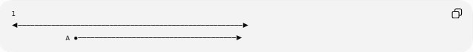
l
◀──────────────────────────────────────────────────────▶
A ●──────────────────────────────────────▶
the ray and line are collinear.
Thus:
$$\boxed{\vec{AB}⊆l}$$

Supporting Line
# Source: AI Source: Provided by: [Data Path: Persons Table -> ID Column: 1, Name_En Column: Motasem Essam] -> From: [ChatGPT] on [7/25/2026]
Every ray has a unique supporting line.
For:
$$\vec{AB}$$
the supporting line is:
$$\boxed{\overset{↔}{AB}}$$
The relationship is:
$$\vec{AB}⊂\overset{↔}{AB}$$
The ray contains only the points extending from $A$through $B$in one direction, while the supporting line continues indefinitely in both directions.
Supporting line:
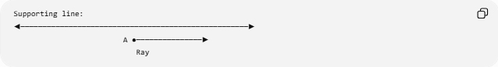
◀────────────────────────────────────────────────────▶
A ●───────────────▶
Ray

Mathematical Representation
# Source: AI Source: Provided by: [Data Path: Persons Table -> ID Column: 1, Name_En Column: Motasem Essam] -> From: [ChatGPT] on [7/25/2026]
A line can be represented parametrically by:
$$r\left(t\right)=A+tv$$
where:
$$t∈R$$
A ray beginning at $A$and extending in the direction of $B$can be represented by:
$$r\left(t\right)=A+t\left(B-A\right)$$
with:
$$\boxed{t≥0}$$
Therefore:
Line: t ∈ ℝ
Ray: t ≥ 0
The ray is a subset of the line.

Point at the Ray Endpoint
# Source: AI Source: Provided by: [Data Path: Persons Table -> ID Column: 1, Name_En Column: Motasem Essam] -> From: [ChatGPT] on [7/25/2026]
Consider:
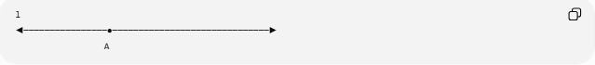
l
◀────────────────●──────────────────────────────▶
A
The endpoint $A$belongs to both the ray and the line:
$$A∈\vec{AB}$$
and:
$$A∈l$$

Points on the Ray
# Source: AI Source: Provided by: [Data Path: Persons Table -> ID Column: 1, Name_En Column: Motasem Essam] -> From: [ChatGPT] on [7/25/2026]
Every point on the ray is also on the supporting line.
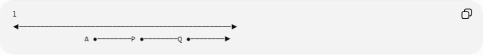
l
◀──────────────────────────────────────────────────▶
A ●────────P ●────────Q ●────────▶
Therefore:
$$P∈\vec{AB}$$
implies:
$$P∈l$$
Similarly:
$$Q∈\vec{AB}$$
implies:
$$Q∈l$$

Ray Does Not Cover the Entire Line
# Source: AI Source: Provided by: [Data Path: Persons Table -> ID Column: 1, Name_En Column: Motasem Essam] -> From: [ChatGPT] on [7/25/2026]
Although:
$$\vec{AB}⊆l$$
the reverse is not true:
$$l⊈\vec{AB}$$
because the line contains points extending in the direction opposite to the ray.
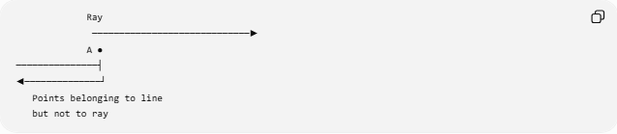
Ray
─────────────────────────────▶
A ●
───────────────┤
◀──────────────┘
Points belonging to line
but not to ray
Therefore:
$$\boxed{\vec{AB}⊊l}$$
for a non-degenerate ray.

Coordinate Representation
# Source: AI Source: Provided by: [Data Path: Persons Table -> ID Column: 1, Name_En Column: Motasem Essam] -> From: [ChatGPT] on [7/25/2026]
Suppose the line is:
$$l:y=2x+1$$
and the ray begins at:
$$A=\left(1 , 3\right)$$
and extends in the direction:
$$B=\left(4 , 9\right)$$
Both satisfy:
$$y=2x+1$$
The ray can be represented as:
$$\left(x , y\right)=\left(1 , 3\right)+t\left(3 , 6\right)$$
with:
$$t≥0$$
Therefore:
$$\boxed{\vec{AB}⊆l}$$
and the ray is ray–line collinear.

Direction Matters
# Source: AI Source: Provided by: [Data Path: Persons Table -> ID Column: 1, Name_En Column: Motasem Essam] -> From: [ChatGPT] on [7/25/2026]
A ray has a direction, while a line does not have a preferred direction.
For example:
$$\vec{AB}$$
and:
$$\vec{BA}$$
are different rays.
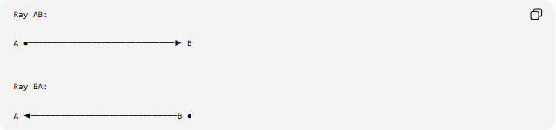
Ray AB:

A ●──────────────────────────────▶ B

Ray BA:

A ◀──────────────────────────────B ●
Both rays lie on the same line:
$$\overset{↔}{AB}$$
Therefore, both are ray–line collinear with that line, even though they extend in opposite directions.

Ray–Line Collinearity vs. Ray–Line Containment
# Source: AI Source: Provided by: [Data Path: Persons Table -> ID Column: 1, Name_En Column: Motasem Essam] -> From: [ChatGPT] on [7/25/2026]
For a ray and its supporting line:
$$\vec{AB}⊆l$$
This can be described in two ways:
Collinearity
Emphasizes:
The ray and line share the same straight-line alignment.
Containment
Emphasizes:
Every point of the ray belongs to the line.
Mathematically, the same configuration satisfies both:
$$\boxed{\vec{AB}⊆l}$$

Ray–Line Intersection
# Source: AI Source: Provided by: [Data Path: Persons Table -> ID Column: 1, Name_En Column: Motasem Essam] -> From: [ChatGPT] on [7/25/2026]
Because the entire ray lies on the line:
$$\boxed{\vec{AB}∩l=\vec{AB}}$$
Their intersection is not just one point.
Compare this with a non-collinear crossing:
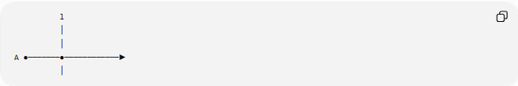
l
│
│
A ●───────●────────────▶
│
Here the line intersects the ray at only one point.
Therefore, the ray and line are not collinear in this case.

Ray–Line Relationship Types
# Source: AI Source: Provided by: [Data Path: Persons Table -> ID Column: 1, Name_En Column: Motasem Essam] -> From: [ChatGPT] on [7/25/2026]
For a ray and a line in a plane, their positional relationship can be classified as:
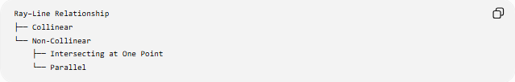
Ray–Line Relationship
├── Collinear
└── Non-Collinear
├── Intersecting at One Point
└── Parallel
Collinear
$$\vec{AB}⊆l$$
One-Point Intersection
$$\vec{AB}∩l=\left\{P\right\}$$
Parallel
$$\vec{AB}∩l=∅$$
and the ray's supporting line is parallel to $l$.

Parallel Ray and Line
# Source: AI Source: Provided by: [Data Path: Persons Table -> ID Column: 1, Name_En Column: Motasem Essam] -> From: [ChatGPT] on [7/25/2026]
A ray and a line can be parallel without being collinear:
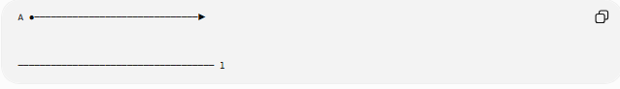
A ●──────────────────────────────▶

──────────────────────────────────── l
Their supporting lines are distinct parallel lines.
Therefore:
$$\boxed{\text{Parallel}≠\text{Collinear}}$$

Collinear Ray and Line
# Source: AI Source: Provided by: [Data Path: Persons Table -> ID Column: 1, Name_En Column: Motasem Essam] -> From: [ChatGPT] on [7/25/2026]
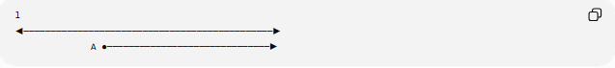
l
◀──────────────────────────────────────────────▶
A ●──────────────────────────────▶
Here:
$$\vec{AB}⊆l$$
and therefore:
$$\vec{AB}∩l=\vec{AB}$$

Important Properties
# Source: AI Source: Provided by: [Data Path: Persons Table -> ID Column: 1, Name_En Column: Motasem Essam] -> From: [ChatGPT] on [7/25/2026]
- A ray and line are ray–line collinear when the entire ray lies on the line.
- The defining relationship is:
$$\boxed{\vec{AB}⊆l}$$
- A ray has one endpoint.
- A line has no endpoints.
- A ray extends infinitely in one direction.
- A line extends infinitely in both directions.
- The ray's supporting line is uniquely determined.
- The ray is a proper subset of its supporting line.
- Their intersection is the entire ray:
$$l∩\vec{AB}=\vec{AB}$$
- A ray can be collinear with a line even when its direction is opposite to another ray on the same line.
- Parallelism and collinearity are distinct relationships.
- Ray–line collinearity is a special case of Line-Object Collinearity.

Comparison with Other Line-Object Collinearity
# Source: AI Source: Provided by: [Data Path: Persons Table -> ID Column: 1, Name_En Column: Motasem Essam] -> From: [ChatGPT] on [7/25/2026]
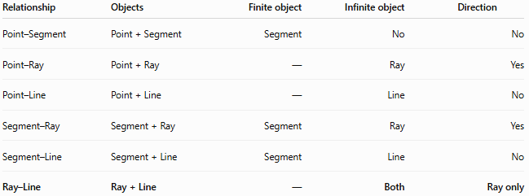
Relationship | Objects | Finite object | Infinite object | Direction
Point–Segment | Point + Segment | Segment | No | No
Point–Ray | Point + Ray | — | Ray | Yes
Point–Line | Point + Line | — | Line | No
Segment–Ray | Segment + Ray | Segment | Ray | Yes
Segment–Line | Segment + Line | Segment | Line | No
Ray–Line | Ray + Line | — | Both | Ray only
The main structural relationship is:
$$\boxed{\text{Ray}⊊\text{Line}}$$

Unified Parameter View
# Source: AI Source: Provided by: [Data Path: Persons Table -> ID Column: 1, Name_En Column: Motasem Essam] -> From: [ChatGPT] on [7/25/2026]
The three basic linear objects can be represented using the same parameterization:
$$r\left(t\right)=A+tv$$
Segment
$$0≤t≤1$$
Ray
$$t≥0$$
Line
$$t∈R$$
Therefore:
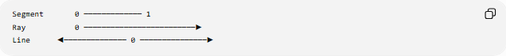
Segment 0 ───────────── 1
Ray 0 ─────────────────────────▶
Line ◀────────────── 0 ───────────────▶
This shows why the ray is contained in the line.

Key Points
# Source: AI Source: Provided by: [Data Path: Persons Table -> ID Column: 1, Name_En Column: Motasem Essam] -> From: [ChatGPT] on [7/25/2026]
- Ray–Line Collinearity means a ray lies entirely on a line.
- Its defining condition is:
$$\boxed{\vec{AB}⊆l}$$
- The ray is infinite in one direction.
- The line is infinite in both directions.
- The ray has one endpoint; the line has none.
- The ray is a proper subset of its supporting line.
- Their intersection is the entire ray.
- The ray's direction does not change its collinearity with the supporting line.

Conclusion
# Source: AI Source: Provided by: [Data Path: Persons Table -> ID Column: 1, Name_En Column: Motasem Essam] -> From: [ChatGPT] on [7/25/2026]
Ray–Line Collinearity describes the relationship between a ray and an infinite line when the ray lies entirely on that line. The essential mathematical relationship is:
$$\boxed{\vec{AB}⊊l}$$
The ray represents one directional portion of the line, while the line continues infinitely in both directions. Thus, ray–line collinearity is simultaneously a collinearity and containment relationship.

